President’s Message
Here we are, it’s February 29th and again, Mother Nature is playing tricks on us. I hope this is her last kick at the can.

As you may all remember, we honoured John Price and Bud Bird (both founding members of our Club) at our Christmas dinner, back in December. In addition, at our February meeting, the Board also bestowed an Honorary Membership to John, who is still an active Club member. We certainly hope that John will join us again at a future event.
Our next event is the Great Winter BBQ on Saturday, March 16 at the Killarney Lodge. We hope to see you all there.

Clifford Kennedy



Happenings From Last Month

The Norway night at George and Barbara’s was a great success! After speaking with several of our members who went, I can tell you everyone was wowed by the tremendous efforts both hosts put into the night!
Not only did they have an amazing presentation to share but had a world class viola player perform, who played with the Moscow Symphony Orchestra! The menu included: caviar, smoked salmon, smoked sturgeon, mussels, pickled herring, shrimp, hot canapés, and assorted cheeses.
George reported to me “Barb pulled out all the stops, when it came to the food!” It sure looks like she did.

Thank you both for putting on such an amazing event! I’m sorry I missed it.

Message from the Club Manager

I’m hoping February has gone by as fast for you as it has for me! It seems like we just arrived here in Mexico and already six weeks have gone by, with only one more to go. It has been a wonderful time, with even better weather. Although, two days of rain is all we had in our seven weeks (by looking at the forecast) those two days made news here. Seems like this time of year is the dry season and there has not been rain in February in 20+ years!

So here we are in our last month of winter. I’m sure it is a joy for many of you. Although, as we all know, March can give us anything, including our biggest snowfalls. So, hopefully the mild winter trend continues.

As I begin to lay down the agenda for our upcoming spring and summer seasons, I again ask you to please feel free to send me some ideas. Things that may interest you. We have a few things coming up and one of which is happening soon! It is important to let me know ASAP, if you plan on attending.

March 16 – 6:00 (6:30 meal) Winter BBQ at Killarney Lake Lodge
Please RSVP no later than March 8.

Happy St Patrick’s Day Everyone!

Francis Perry

DATES TO MARK ON THE CALENDAR

March 16 – 6:00 - drinks, 6:30 - meal: Winter BBQ at Killarney Lake Lodge.
RSVP by March 8.

March 23 – 6:00 & 8:00 – 6:00, supper out followed by Virtual Reality Escape Room at 8:00.
RSVP by March 16.



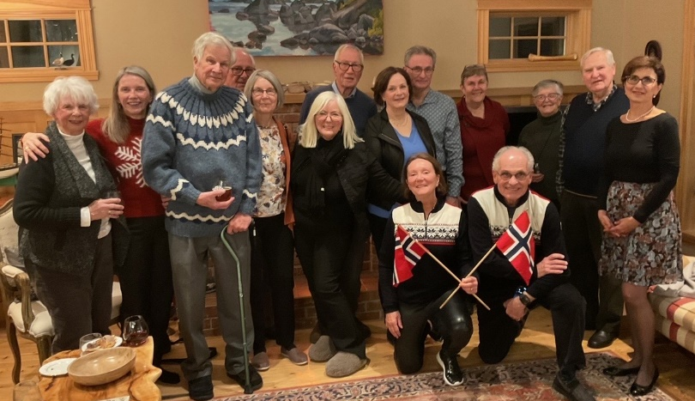

Photos from the Norway Night

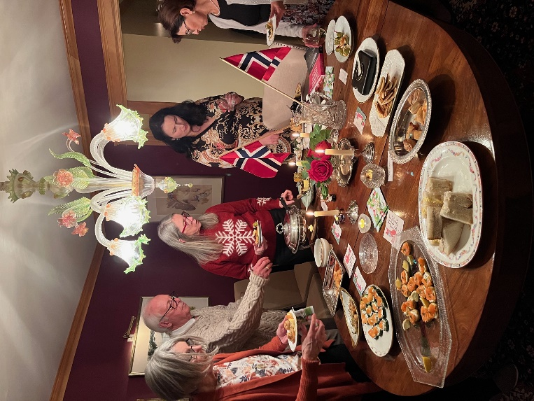

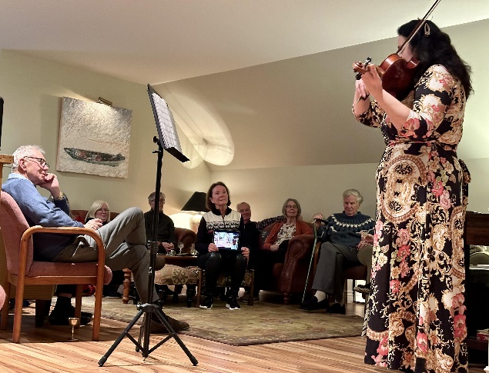

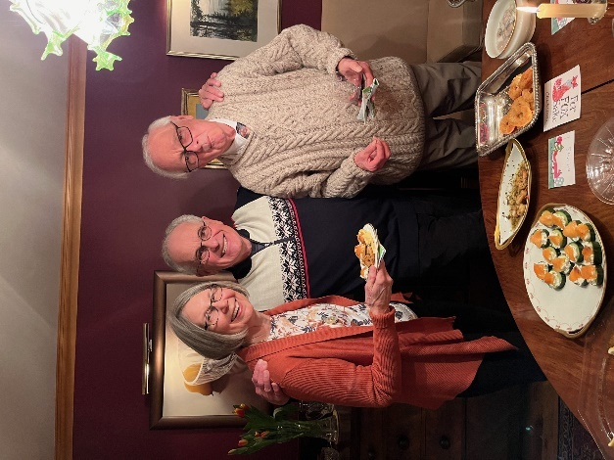




DISPATCHES
March 2024



The Fredericton Garrison Club Inc.
www.garrisonclub.org
454-6744

