
President’s Message
The years go by so fast. Isn’t that a song?
Our club has been in existence for what some would say is a millennia. And, in a way, that’s kinda true.
As we crawl out of winter’s embrace with the snow and disgusting freezing rain, we look forward to spring flowers, our BBQ and (maybe with luck) a History Tour #21. Plans for our AGM are ongoing where the gavel will pass once again to Cliff Kennedy, a longtime member and past president. Some of you may know him, quiet unassuming chap.
The days are growing longer. Enjoy and get ready for spring!

Jim Quigley



Message from the Club Manager

Happy February Everyone! As I write this, I’m very warm here in Mexico. I’m hoping you are somewhere warm or at least all cozy in your home.

There are several things happening that I want to bring to your attention. Some coming up very soon!

February 3 – 7:00 – Norway/Cruise as seen through the eyes of George and Barbara
George and Barbara have offered to hold one of the Club’s favourites (gone for several years). In November, they visited this Fire and Ice country and have some wonderful photos and stories. If you have not been to one of their travel chats, you have been missing out. Since this event will be at their home (26 Apeldoorn Lane) this event has a limit of 20 people.
If you feel like bringing a Norwegian style appetizer dish, by all means, Google a recipe. Also, please BYOB.
Please RSVP by January 27.
Jumpins, January went by fast! In saying this, we are currently enjoying ourselves in the land of Tequila, (Mexico). Don’t worry, we are relatively safe in Puerto Vallarta.
We return on February 19, to just be off to Cuba for three weeks, seven days later.

As you might have heard, our wonderful President and longtime Club member, Jim Quigley, is leaving us! Although we will all miss him and Linda, life is about the pursuit of happiness and fulfillment, and I’m sure there is nothing better than being around family and friends back in Newfoundland. Stay tuned for date when we might be able to have a nice send off for them.

You will have already heard about some of the following, but we sure would like a few more numbers. The first one is February 4, at 6:00. Dine Around Freddy at the spectacular St. James Gate Restaurant at the West Hills Golf Club. We already have a few members going but, by all means, feel free to invite some friends and enjoy a wonderful evening out in Fredericton. Since I will be away at this point, please call the restaurant and add your name to the reservation under the Club. 506 206-9609.

February 24, at 5:00. Come join us for a wonderful old fashion horse and sleigh ride at Sandwith’s Sleigh Rides. They do require a minimum of 10 people to make this a go… currently we have 4. Enjoy a sleigh ride in a nice, wooded lot along with a bonfire, some hot chocolate and homemade cookies. If you are interested, they can also do a meal. See the Jan. notice that is attached here again. RSVP by Feb. 18th.

March 24, 6:00 with dinner at 6:30 – Killarney Lake Lodge for our winter BBQ. The lodge is big, and the tables are set well away from each other. Tables will be set for 8 people. But they are big, so you are not sitting on top of each other. Come enjoy a BBQ treat in mid-winter. Steak or Chicken and Ribs.
RSVP by March 18th.

The following is off in the near future, but we wanted to inform you now, so that you can mark it in your calendars. Our AGM and spring Lobster BBQ will be Friday, June 2. AGM at 5:00, followed by a cocktail hour and a meal.
As we look ahead to spring and summer, I’m asking you for your help. What kinds of things would you l https://unpluggednoescape.resova.us/items/view/17
ike to suggest/see/do? We sure have had a hard couple of years. COVID has made it a struggle to get people out to any of the events. I’m hoping now that things are getting closer and closer to normal, that we might have some more interest a.


Francis Perry


DATES TO MARK ON THE CALENDAR


February 3 – 7:00: George and Barbara speak on their wonderful trip to Norway. 20-person capacity, RSVP ASAP

March 16 – 6:00 - drinks, 6:30 - meal: Winter BBQ at Killarney Lake Lodge.
RSVP by March 8.

March 23 – 6:00 & 8:00 – 6:00, supper out followed by Virtual Reality Escape Room at 8:00.
RSVP by March 16.

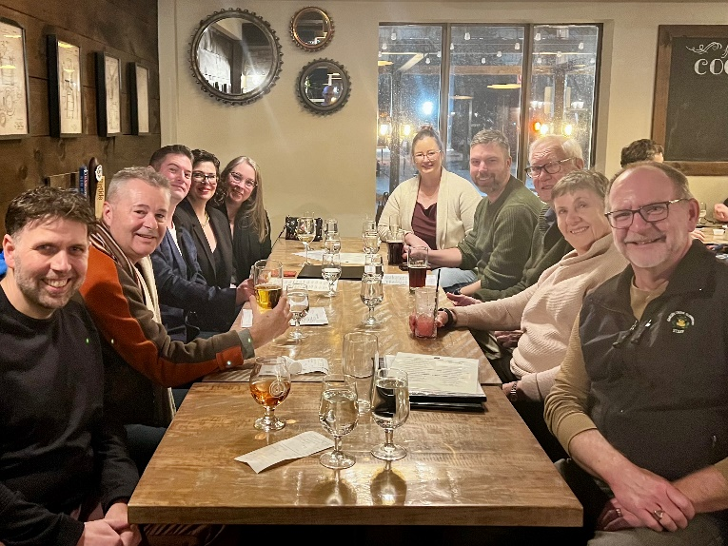

Photos from The Joyce, 540 Kitchen and The Pickle Jar n & Jazz

Photos from January’s
It’s Cold but it’s warm in here!

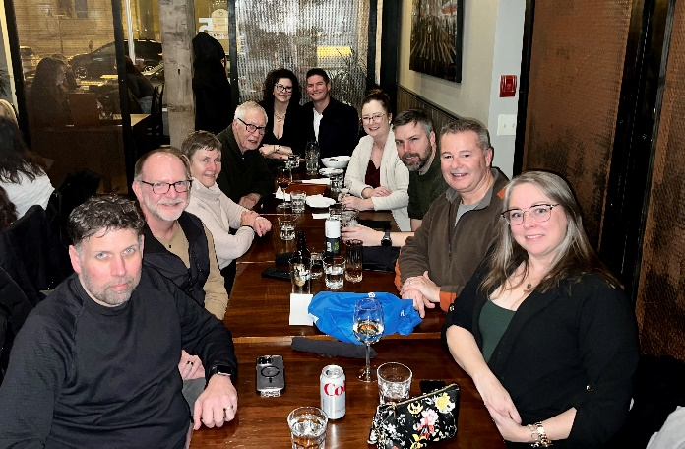

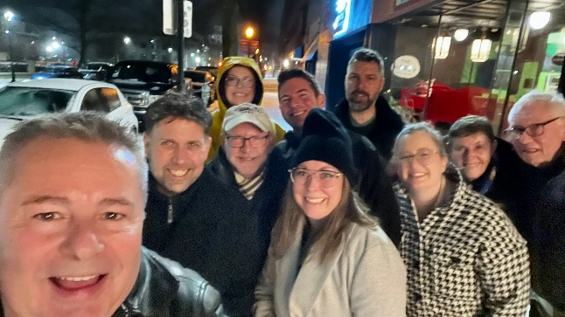

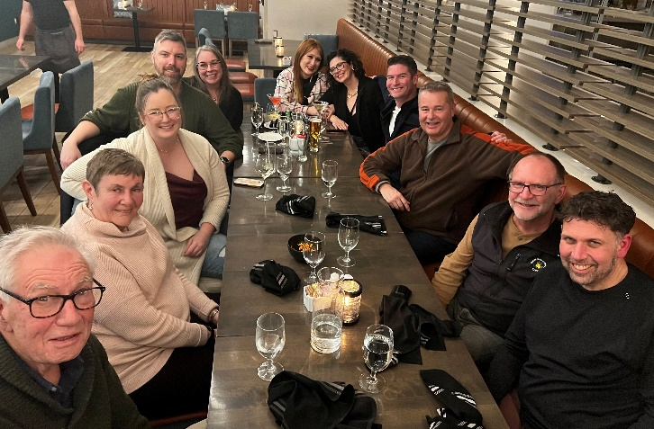



DISPATCHES
February 2024




The Fredericton Garrison Club Inc.
www.garrisonclub.org
454-6744

